**4COSCO11C.2 Web Design and Development**

**Tutorial 2**

### Task 1 - Create your Web Page content

Create a file and save it as **tutorial2.html**

Your Web Page should follow the following specifications.

#### **Part 1**

* Tutorial 2 for the title.
* Pool Schedule (your name) as the page heading
* The schedule shown below in a HTML table.
* The first row of the table should contain the prices shown using a list. You may need to use a HTML entity **&#163;** to display the '£' sign correctly. HTML character entities are used to display reserved characters.
* Demonstrate the use of both rowspan and colspan in the table.
* A ruler acting as a separator.
* Your email address inside an address element.
* The last modified date (just add today's date (hard coded)).
* See the following image for an example of the layout.
* Remember, you can check if your markup is syntactically valid using the Validator at: <https://validator.w3.org/>  
  + Use the ‘Validate by File Upload’ or ‘Validate by Direct Input’.

#### **Part 2**

* Use CSS to style the Schedule. For example, give repeated items (such as SwimFit, Lane Swim) matching text or background colours.
  + Use an embedded style sheet and do NOT use inline styles.
  + Use a class to identify repeated items and apply a colour for each class.
* Additional CSS.
  + Experiment with padding to make space around the text within the <td>s.
  + Experiment with the different border-style values: solid, dotted, dashed, double, groove, ridge, inset and outset.
  + Experiment with the border declarations:
    - border-collapse: collapse;
    - border-collapse: separate;
  + Experiment with the unordered list styles: square, circle, disc (default), and none.

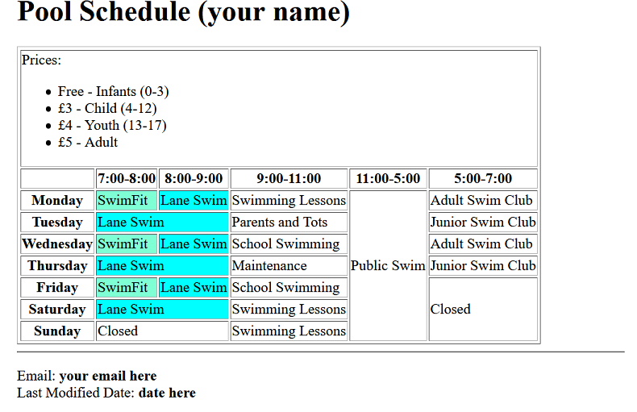

Task 2 - Complete the Tutorial Test on Blackboard

* Go to Assessment -> Tutorial Tests -> Tutorial 2 Test and complete the test. You can have up to five attempts to get the maximum score of 2 marks.